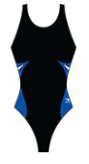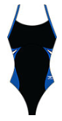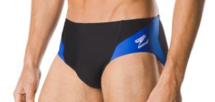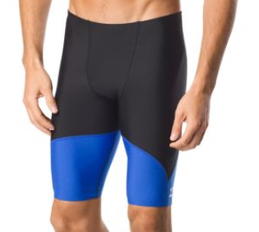

Normandy Suit for 2019

Speedo

Spark Splice Black/Blue Suit

Two Options for Girls:

* Flyback – Thin Straps
* Proback – Thick Straps

Two Options for Boys:

* Jammer
* Brief